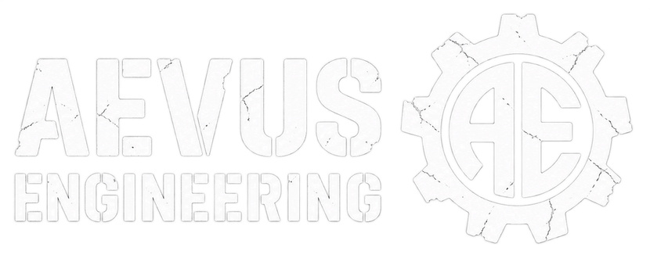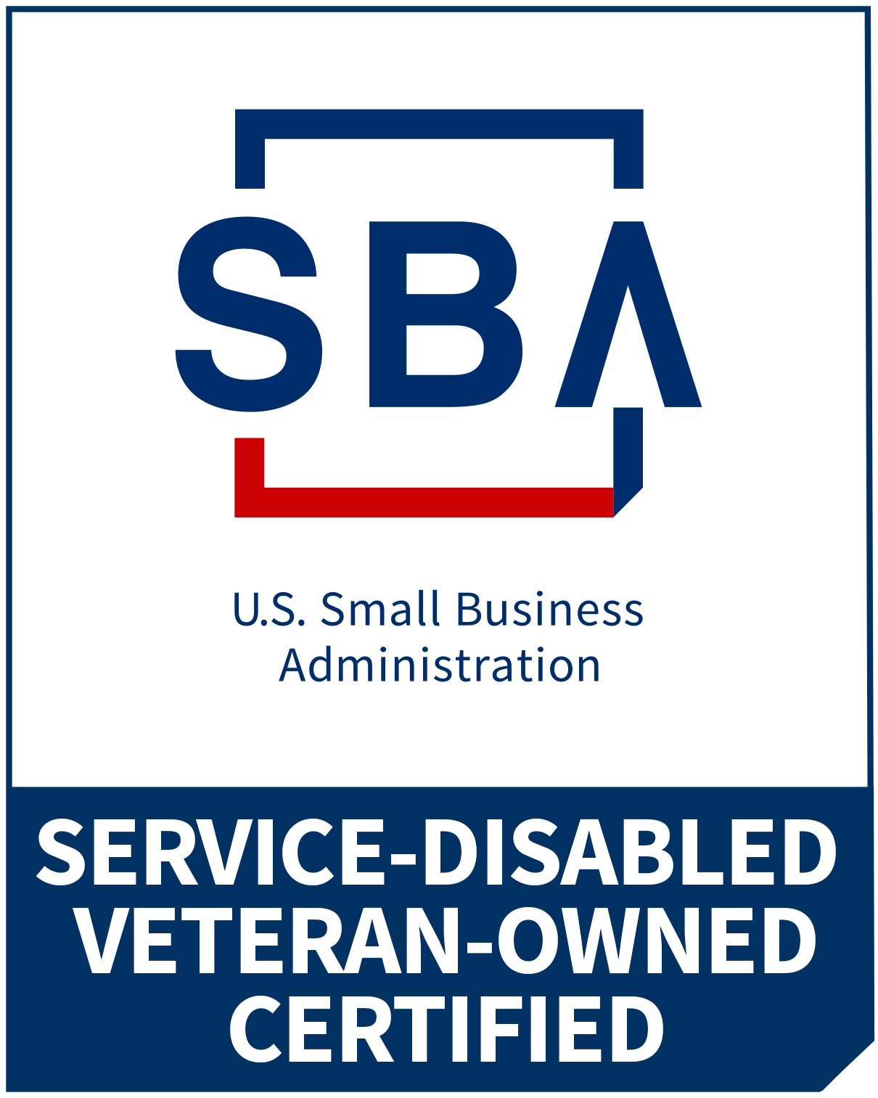

AEVUS Engineering Capability Statement
AEVUS Engineering supports agencies and prime contractors with software development and sustainment, engineering test readiness, data integration, technical coordination, workflow modernization, and practical AI automation. We turn requirements into defined work, usable systems, and documented evidence.
SDVOSB | UEI GU5KEGZ1UQQ1 | CAGE 124S2 | PRIMARY NAICS 541330

Core competencies
Software sustainment and development
Custom web, mobile, and internal applications; software maintenance; system integrations; and modernization of legacy workflows.
Test readiness and data integration
Engineering test support, readiness reviews, test-system interfaces, data aggregation, and test-stand utilization workflows.
Engineering and technical services
Requirements definition, technical documentation, validation planning, program coordination, and stakeholder alignment.
System and workflow modernization
Process mapping, digital workflow design, internal tools, automation, and improved visibility across operating teams.
Agile DevOps and delivery execution
Incremental delivery, release planning, change control, and evidence-based acceptance across software, engineering, and operations.
AI workflow implementation
Bounded assistants and agents using approved business data, defined permissions, human review, acceptance checks, and operational handoff.

Typical deliverables
- Requirements and interface map
- Readiness findings and action plan
- Integration or modernization roadmap
- Working software or automation increment
- Test evidence, documentation, and handoff package

How AEVUS supports a requirement
- Software modernization and sustainment
- Engineering test readiness and data visibility
- Requirements, documentation, and technical coordination
- AI and workflow automation with human review
- Prime contractor teaming and scoped technical support

Relevant leadership experience
Founder Craig A. Petronella’s earlier military and industry roles; not contracts awarded to AEVUS.
- Led multi-site software development and integration for engineering test labs, improving interoperability and data accuracy.
- Supported global software rollouts with zero downtime, improving system resilience and user experience.
- Modernized test-stand utilization software and associated operating workflows.
- Supported the Fort Eustis Army aircraft engine test-cell modernization project.

Why AEVUS
- Founder brings 10 years of Fortune 50 experience across technology, engineering, and operations.
- U.S. Army veteran with aviation maintenance, phase maintenance, quality control, production control, and crew-management experience.
- Founder qualifications include Lean Six Sigma Green Belt and Design for Six Sigma Black Belt.
- Experience supporting large-scale system modernization and mission-critical software deployments.
- Experience working within CFR and Department of Defense policy frameworks.

Business profile
Service-Disabled Veteran-Owned Certified
Michigan, United States
UEI GU5KEGZ1UQQ1 | CAGE 124S2

NAICS service areas
541330 Engineering Services (primary focus)
541511 Custom Computer Programming Services
541512 Computer Systems Design Services
541519 Other Computer Related Services
541618 Other Management Consulting Services

Contact and teaming
Craig A. Petronella
Founder
(810) 256-0280
craig.petronella@aevuseng.com
www.aevuseng.com
Updated October 10, 2026

